**Filters in Search Views (XML)**

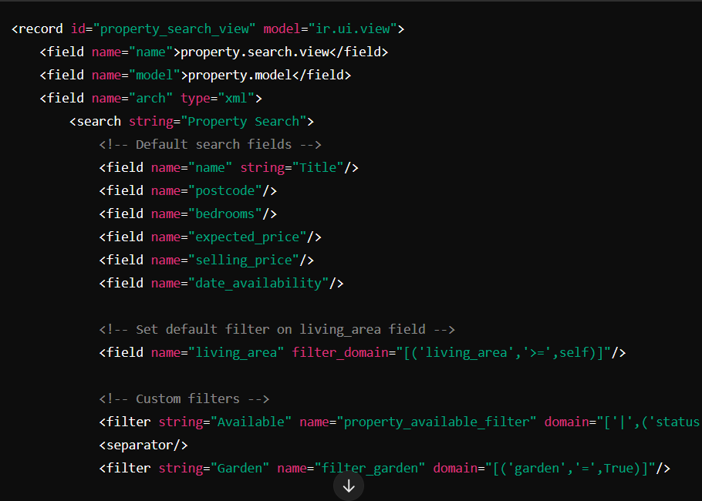

<filter   
 string="Available"   
 name="**property_available_filter**"   
 domain="['|',('status','=','new'),('status','=','offer_received')]"   
/>

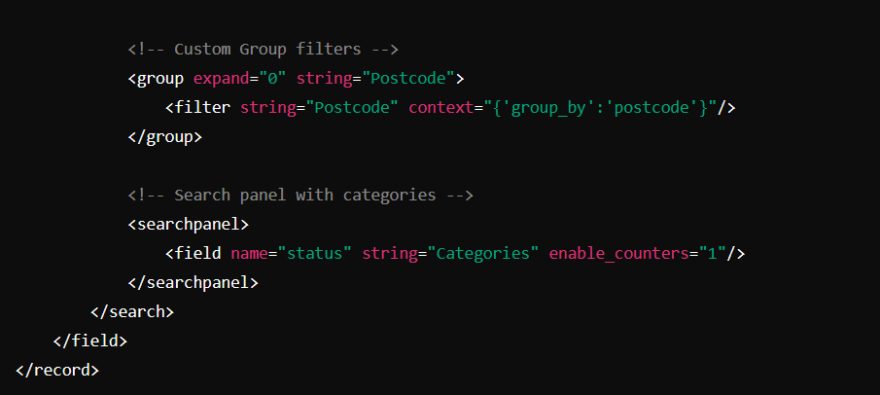

You can set a default filter directly in a window action. This is useful for actions that open a specific view with pre-applied filters.

**Example of a window action with a default filter:**

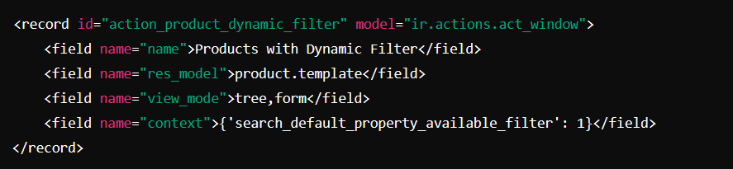

* **Sef a default filter using context**
* <filter   
   string="Available"   
   name="**property_available_filter**"   
   domain="['|',('status','=','new'),('status','=','offer_received')]"   
  />
* {‘search_default_ **property_available_filter**’ : 1}